SQL Server Reporting Services

Powered by MIRACLE ADVANCE TECHNOLOGY.

Microsoft SQL Server 2019 Reporting Services Download link

CONFIGURATION
- Install
- Report Server Connection
- Have to connect with own pc’s name and press Connect
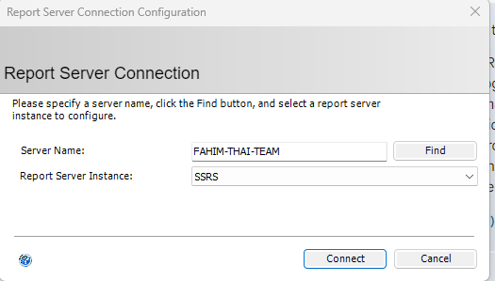

- Service account
-Use built-in account: Network Service and press apply
Web service URL
Just press Apply
- Database ,
- Click on Change Database
- Select Create a new report server database
- Server name will be your own SSMS server name.
- Authentication Type : Current User
- Press Next
- Authentication Type service credential.
- Press Next and it will start progressing

Click to web portal url and press apply
After that click to URLs.

Now Go to Backend Project - Petmatrix-backend-psu and Run on Visual Studio.
- Click on PetMatrix.Reporting from solution explorer.
- Click on Shared Data Sources and expand
- Copy the .rds file name
Now go back to Web Portal URL link and Click on Plus Button and select Data Source
- Paste the .rds file name that you copied.
- Connection Type Will be Microsoft SQL server
- Copy the connection string from Petmatrix backend Project
- On the Credentials part select Using the Following Credentials
  - On type of credentials select Database username and password
  - And type username and password from SSMS credentials.
  - And press Test Connection and after connection is successful press Create.
- Now GO to petmatrix Backend Project and in the solution explorer expand PetMatrix.ReportViewer and select web.config.
- Now press ctrl+F and search for ReportServerUrl and change the value from (Go to Web service URL and click on the URls link and copy the URL from the browser.)
- Change rsUserName to your PC name
- Change rsPassword to your PC Password
- Now, ReportPath and copy Only the report path Name . ex: PetMatrixPSU.Reporting
- Go back to the Web Portal URL link and From plus icon create a folder with the name you copied.
-Now from petmatrix backend go to PetMatrix.Reporting properties and change
TargetReportPartFolder and Target server URL to ReportServerUrl value from PetMatrix.ReportViewer -> web.config. And click apply

Also click on the Web service URL menu and Click URLs.

SETUP
- Create datasource and set connection string.
- Go to web config , copy (petMatrixPSU.reporting )name and using this name create a folder in reporting server.
- Go to webconfig and have to give url with browse link of web service url, username will be own PC’s name, password will be PC’s password.

PUBLISHING
- Go to petmatrix.reporting properties -
- change the path of targetReportPartFolder && target sarverVersion with collected server link (from internal group)..
- Have to change target report folder name according to where will be published the report.

- Finally select deploy option to publish the report.

